**Smita Holidays Website Update to Be Done**

**a)Front End – Home Page**

1. Heading – Replace Though to Through

2. Category Box Showcased are wrong – Only Active Category need to be Showcased and sequence Management must be there.

3. Similarly for Search Box the itinerary Suggestion must be of Only Active Category.

*4. Safety Text and Image Attached with the file.

5. SHP Icon Change for 1: Plan 2: Invest; How it Works needs more space between words. And Add ? to it >>> How It Works ?

6. Instead of Affiliated Partners change to - What Set’s Us Apart

7. At Partner Logos Share us Logo Size so we can add accordingly (At Present no Logo is Shown)

*8. For Footer Section Check This Image: 4 Column Sequence as Shown

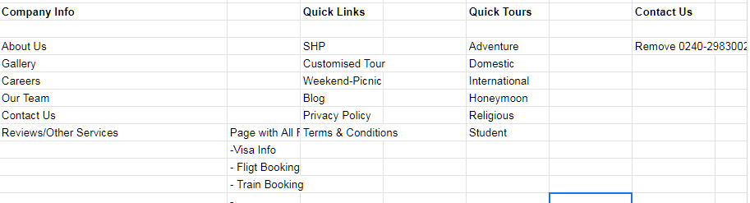

b) **Front End – SHP Page**

1. Search Box (Suggestion Need Only for SHP Category)- After Search: On Page only should display Tour Listing.

*2. SHP Points – Spelling Correction: Safety(5th line) & Last Line Update

“One instalment is free from Smita Holidays or Weekend Tour”

3. On Hover/Beside Heart Logo-Text (Add to wishlist)

4. Above Tour Listing Add 4 Boxes with Text as Shown

Travel to Destination

Pay 12th SHP

Start SHP

Check Monthly Instalment

Choose Destination

5. Request for Customize - Redirect to Customized Tour with same tour name pre define

6. SHP Video Link - <https://youtu.be/rq-zD5x95Ec>

7. Tour Details Page Replace “About this tour” to – “Highlights ”

8. Pricing Part: Starting From ₹ 1200/- Per Person Per Month. With T.C. Apply Icon

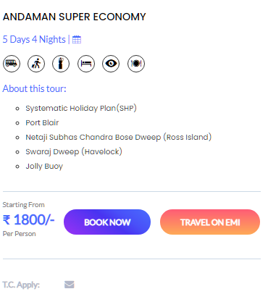

Per Person Per Month

T.C. Apply:

9. Tour Details DAYS Tab Access Required –

10. Replace Travel on EMI with Travel with SHP

11. Email Option to Tab After Days

11. After an Itinerary Add Book Now (Button)

**c) Front End (About Us Page)**

1. Change Spelling Winters to – Witness (2nd Column – 2nd line)

**d) Front End (All Tour Category)**

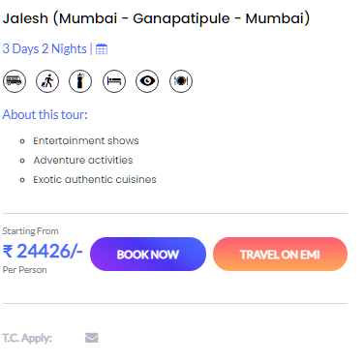  

1. Per Person

T.C. Apply:

2. Tour Details Page DAYS Tab Access Required

3. After an Itinerary Add Book Now (Button)

**e) Front End (Careers)**

Replace Text : Any kind of travel information don't hesitate to contact with us for immediate customer support. We are love to hear from you.

To: Join our Great Team of Talented Individuals in a Dynamic and high-growth Industry.

**f)Backend**

1) Access Required

> Category Add/ Delete with Sequence Arrangement

> Sign in Details and Access

> Top Destinations & Top Deals Setting up Access

> Smita Points Set/Add/ Delete/Edit Access

> Sequence Arrangement of Tours Access

g) Backend (Tour Adding Issue)

> Old Tour Data Country set Wrong (Proper Link to Old Data)

> When we try to update any Tour the Default tour type is SHP in Backend.

>