RESUME

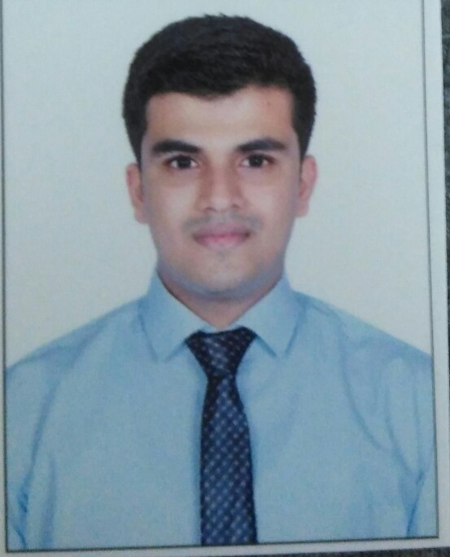

**Mr. Gaurish Vasant Prabhu**

Contact No. 8657458841

E-mail address : [gaurishvp@gmail.com](mailto:gaurishvp@gmail.com)

**CAREER OBJECTIVE**

To learn, improve and excel in my profession & corporate world by obtaining a

rewarding position by contributing my entire knowledge and experience in my field.

**EDUCATIONAL QUALIFICATION**

|  |  |  |  |  |
| --- | --- | --- | --- | --- |
| **Exam** | **School/College** | **Board/University** | **Year of passing** | **Percentage of marks** |
| S.S.C | St Xavier’s High School,Goregaon(E). | Maharashtra | 2011 | 65% |
| H.S.C | Patkar College, Goregoan (E) | Maharashtra | 2012 | 55% |
| B.S.C in Hospitality Studies and Catering Science | Atithi School Of Hospitality & Management | YCMOU | 2017 | 62% |
| Msc in Hospitality Studies and Tourism Management | Madhurai Kamraj University | Madhurai Kamraj University | 2019 | 72% |

**WORK EXPERIENCE:**

**THE** **WESTIN MUMBAI GARDEN CITY, MUMBAI (2017-2018)**

**Designation:** Front office Associate

**Job Role:** Taking care of guest registration, handling guest complaint, managing restaurant booking, air ticket, handling guest luggage etc.

**Kesari Tours Pvt Ltd, Mumbai (2019- 2020)**

**Designation:** Guest Relation cum Tour Leader

**Job Role:** Taking care of guest complaint and solving queries. Taking care of guest while they are on tour.

**Patkar Varde College, Mumbai (2021)**

**Designation:** Public Relation Officer and Lecturer for Masters in Travel and Tourism Course.

**Job Role:** Managing reputation of organization by various sources and taking lectures for masters students.

**INTERNSHIP:**

**Hotel Name:-**Sahara Star, Mumbai (4th June to 3rd Sep 2015)

**Departments:-**Food and Beverage Service. (1 month)

Front Office (2 Months)

**CURLICULAM ACTIVITIES:**

1. Participated in Young Turks Food Festival.
2. Participated in Chocolate Making Competition.
3. Participated in College Theme Lunch.
4. Participated in various college events like Christmas, Eid, Chetichand, Diwali throughout my academics years.
5. Invited for Board of Studies Meeting for Masters in Travel and Tourism course

**ACHIVEMENTS:**

* Awarded as a Star Performer at Kesari Tours Pvt Ltd.
* Awarded as a Kesrian Of The Month at Kesari Tours Pvt Ltd.
* Awarded by Westin Mumbai Garden City for good work.
* Awarded by JW Marriott Juhu, for highest number of waiting hours (225 hrs) in 2014-2015.
* Winner OF Culinary Olympic (YTFF) 2016
* Winner in Chocolate Making Competition 2016-2017

**STRENGTHS :**

* Innovative
* Optimistic
* Determined
* Leadership skill
* Self-Motivated

**HOBBIES AND INTERESTS :**

* Photography
* Playing Badminton , Cricket
* Surfing on Internet

**PERSONAL DETAILS**

Date of Birth : 09/03/1994

Sex : Male

Marital Status : Single

Nationality : Indian.

Languages Known: English, Hindi and Marathi, French (Learning).

**DECLARATION :**

The information given above is true to the best of my knowledge and I will be responsible for any flaws in it.

DATE:

PLACE: Mumbai.

GAURISH VASANT PRABHU