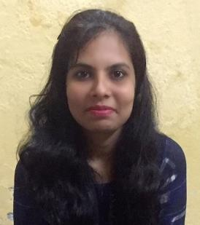

**BIO DATA**

Name:Dipika Abhijeet Ghodke (Bagul)

DOB: 29-Jan-1991 Gender: Female

Marital Status: Married Religion: Hindu

Email Id: [deepikabagul291@gmail.com](mailto:deepikabagul291@gmail.com) Mobile No: 9404266995 Language Known: English, Marathi, Hindi

# Educational Details

|  |  |  |  |
| --- | --- | --- | --- |
| **Education** | **Institute Name** | **Year of passing** | **Marks** |
| **S.S.C.** | H.R.Patel High School, Shirpur | March 2006 | 72.00% |
| **H.S.C.** | H.R.Patel Junior College, Shirpur | Feb 2008 | 60.50% |
| **B.C.A (T.Y)** | R.C.Patel IMRD College, Shirpur | May 2014 | Appeared |

**Work Experience**

Fresher

# Hobbies & Interest

Computers, Reading, Travelling.

# Address

C/O. P.D.Patil, Plot No.17, Gut No.92, Peshwe Nagar, Behind Ration Shop, Satara Parisar, Aurangabad – 431010

**Declaration:** I hereby declare that all the information provided here is true to the best of my knowledge.

Place: Aurangabad

Date: Signature